**NOIDA INSTITUTE OF ENGINEERING AND TECHNOLOGY, GREATER NOIDA**

**SEMESTER-Even**

**UNIT: 1 ASSIGNMENT 1.3**

**Subject Name: Design Thinking I**

**Q1 Case Study: Floresia- Design The change**

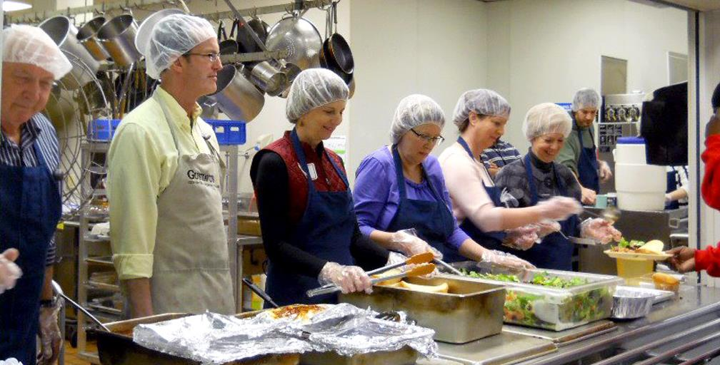

Floresia, a country well known as elderly-friendly, was facing one of their gravest mysteries with respect to taking care of elders of the nation. The country that was constantly rated in top 5 since 1970s in every survey related to taking care of elders, did not even feature in top 10 since 2005. Though these surveys took multiple factors into account, one important parameter was enough to bring the final ratings down. The factor was: diet of the elderly citizens.

Let’s take a look at some of the crucial statistics to understand how grave the situation was:

* As many as 80% of the elderly population stayed in Old-age homes, higher by all

standards

* Most of these 80 % (further data not available) elders have their daily meals at the

Municipality/Municipal Corporation subsidized canteens. There is one such canteen at

each suburb in a town.

* An estimated 60% of these elders have poor nutritional value
* 20% are malnourished

Most of the elderly population had been earning throughout the life by serving government or private organizations and retired at their natural age of 60. Many of the elders cooked food in their yesteryears and have decent knowledge of peculiarities of food in different seasons of Floresia. Unfortunately, in this stage of life they are at the helms of Old-age homes.  
For their daily meals, they receive subsidized food from the respective municipality canteens. These meals are government sponsored meals for which funds are allocated each year by the Central Government of Floresia. It is interesting to note that, 2% of GDP of Floresia is especially dedicated for programmes meant for taking care of elderly. Successive governments have ensured no compromise on this initiative. With minimal corruption in bureaucracy, the funds allocated reach the intended beneficiaries.

Canteen: Each canteen goes by the name “<Name of the town> Subsidized Canteen for Elderly”. Such branches of canteen exist in each suburb and are easily accessible to all the elderly. Accessibility was never the issue. The service in the canteen too was not complained by the elderly.

Food, cook in the canteen: The food items in the canteen menu take adequate care of the nutritional value of elderly. Additionally, the employees employed in the canteen also were qualified.

Sanitation & Hygiene in the canteen: The elders never complained about the sanitation and hygiene in the canteen. The cleanliness of the canteen was on par with many posh restaurants of Floresia.

**The Challenge -**

You are hired by the Ministry of Human Resources of Floresia as a consultant to look into this challenge and suggest the next course of action. Despite continuously maintaining a healthy budget (highest in the continent with respect to % of GDP and one of the highest in the world despite having fewer elders), ensuring highest quality of hygiene & sanitation, deploying knowledgeable and able staff in the canteen, why are the elderly poor in nutritional value and seriously malnourished? As a consultant, your job is to suggest a feasible, economical and importantly sustainable idea.

Q2 What comes to your mind when you think of :



Q3 Write down as many scenarios where you have seen Design thinking being applied around you

Q4 Give examples of 3 good design around you

Q5 Give examples of 3 bad design around you

Q6 What is a difference between Empathy and Sympathy

Q7 Explain the 5-step process of Design thinking

Q8 Elaborate Arcturtus IV case study

Q9 What all can be designed? Give instances

Q10 what are different design approaches followed in the world? Explain any two in detail